Smart Premium: Predicting Insurance Costs with Machine Learning – Documentation
STEP 1: Complete EDA and Preprocessing Notebook
Load datasets and inspection the data
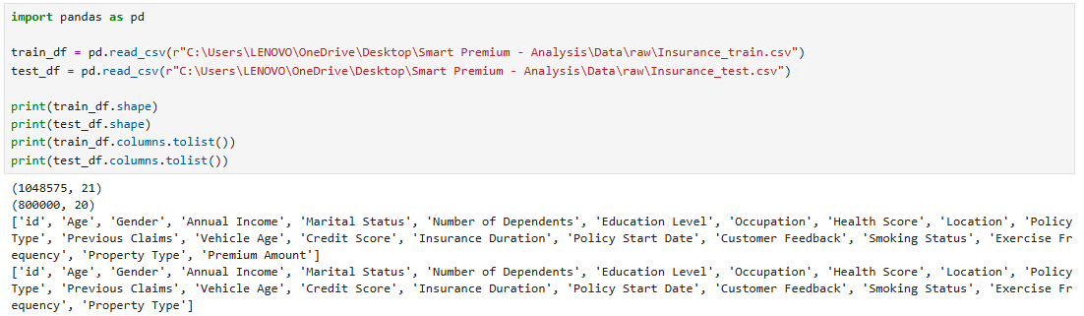
Train the dataset
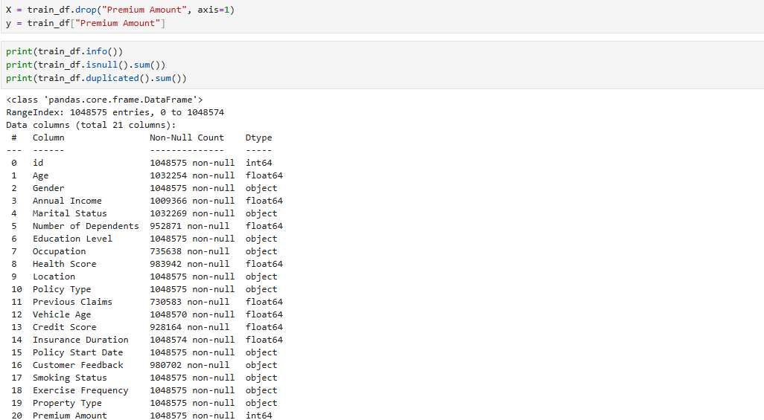
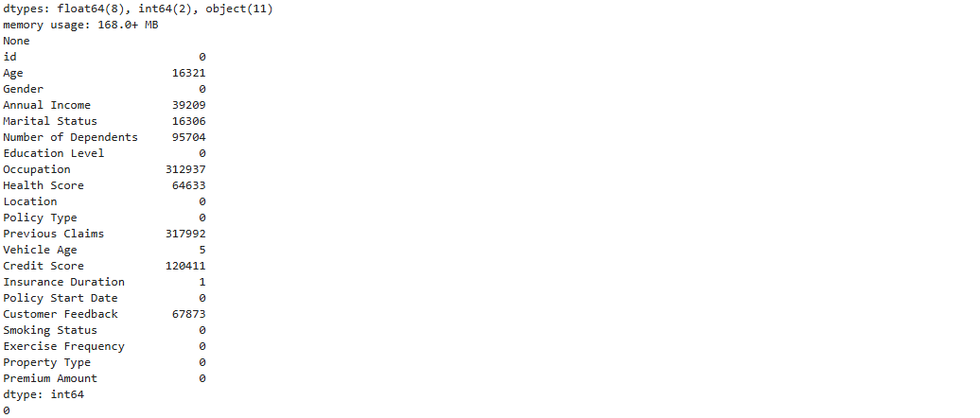
Train and test data columns
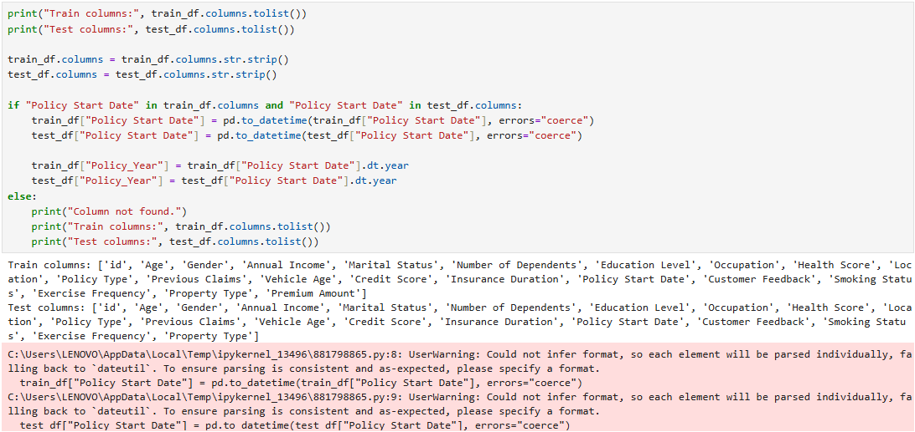
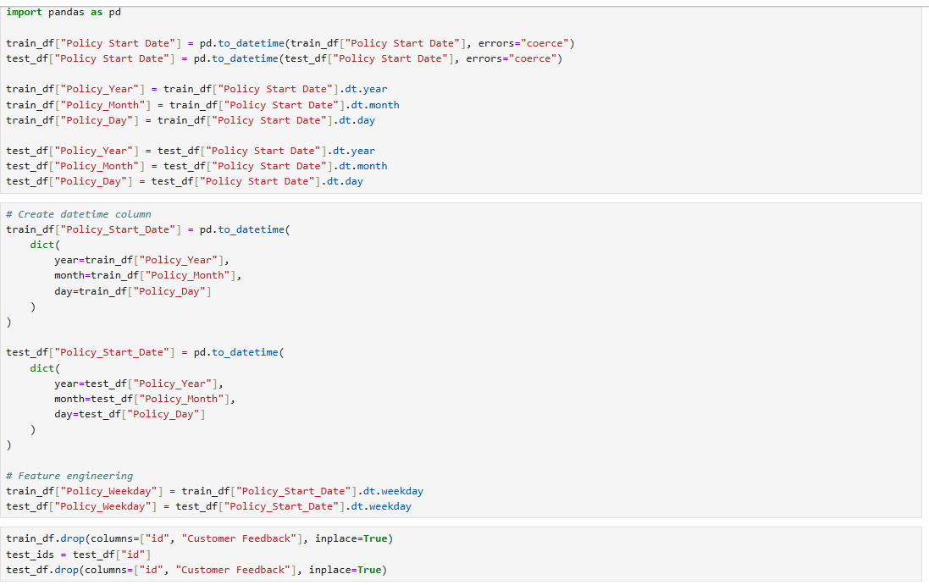
Target distribution
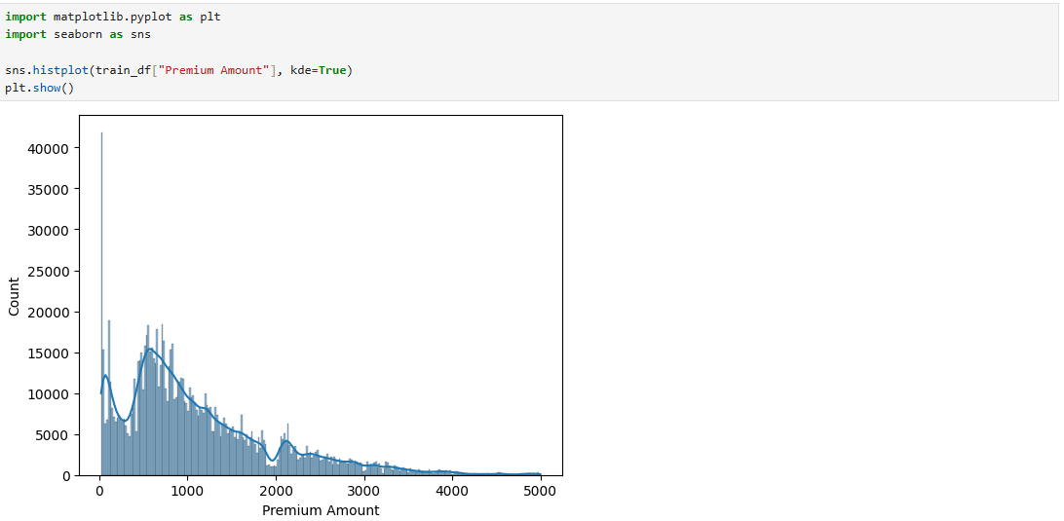
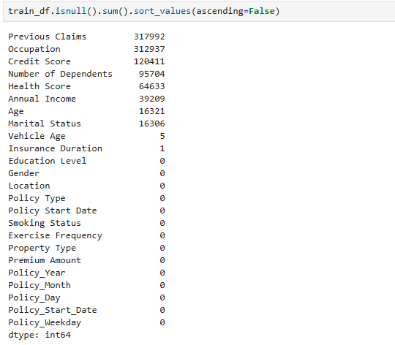
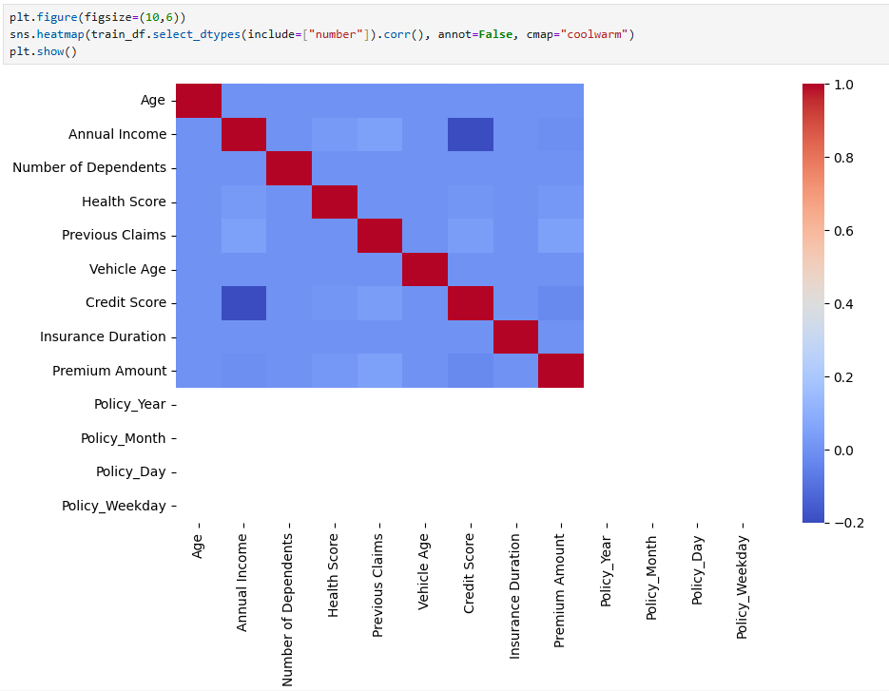
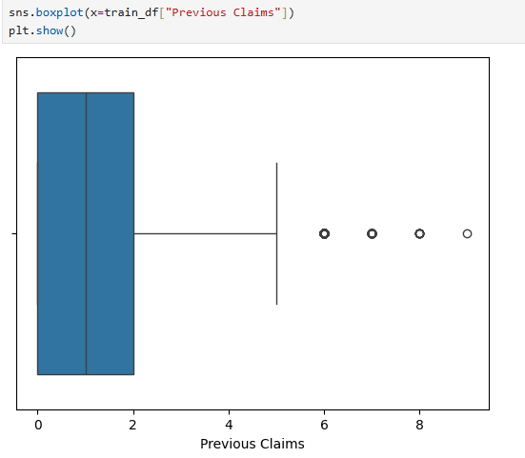
Machine learning build
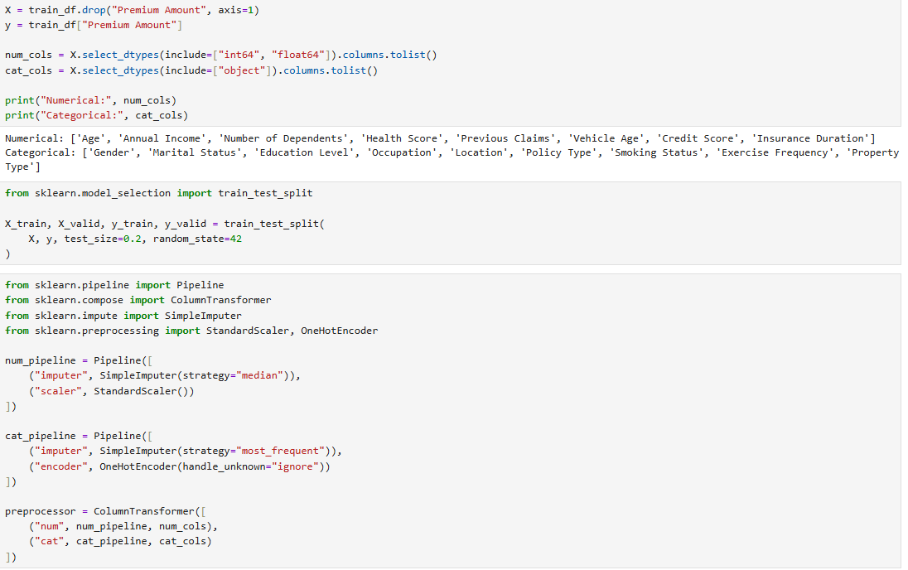
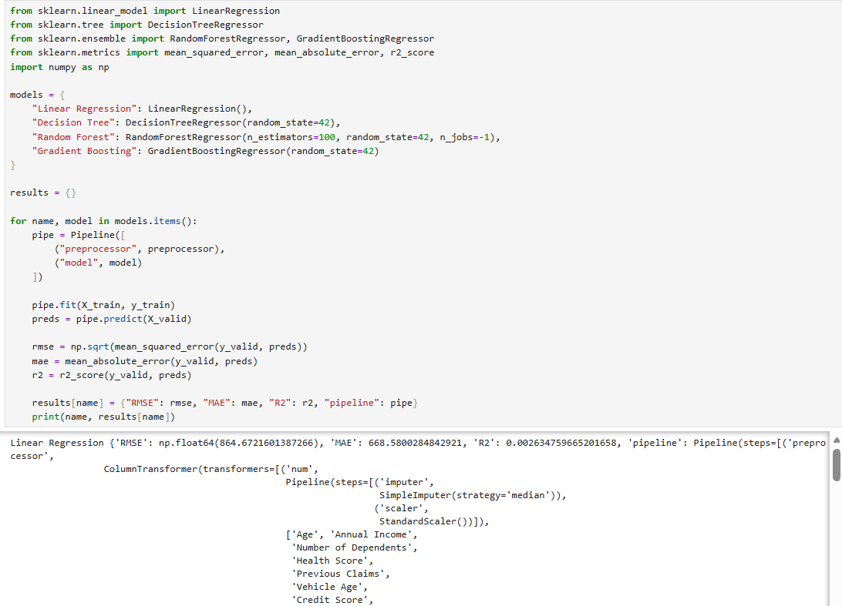
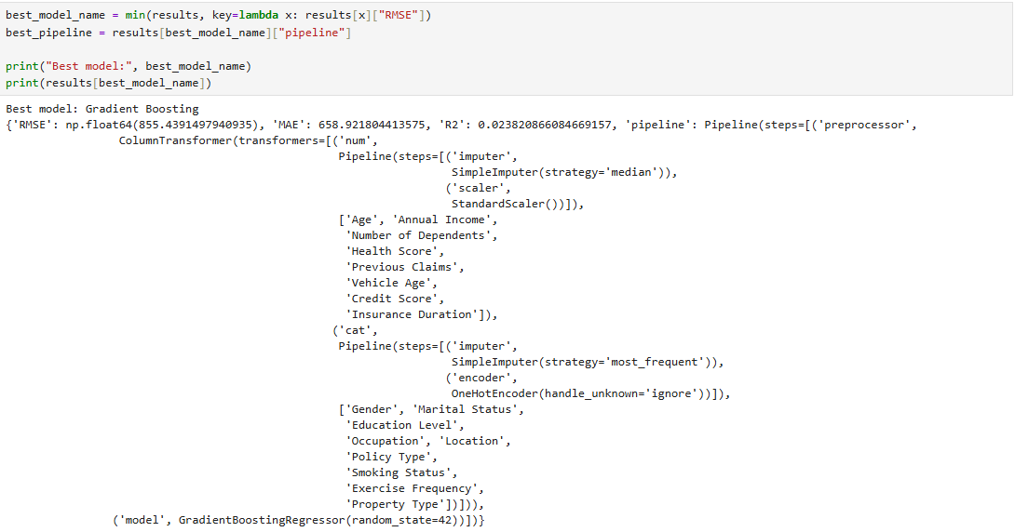
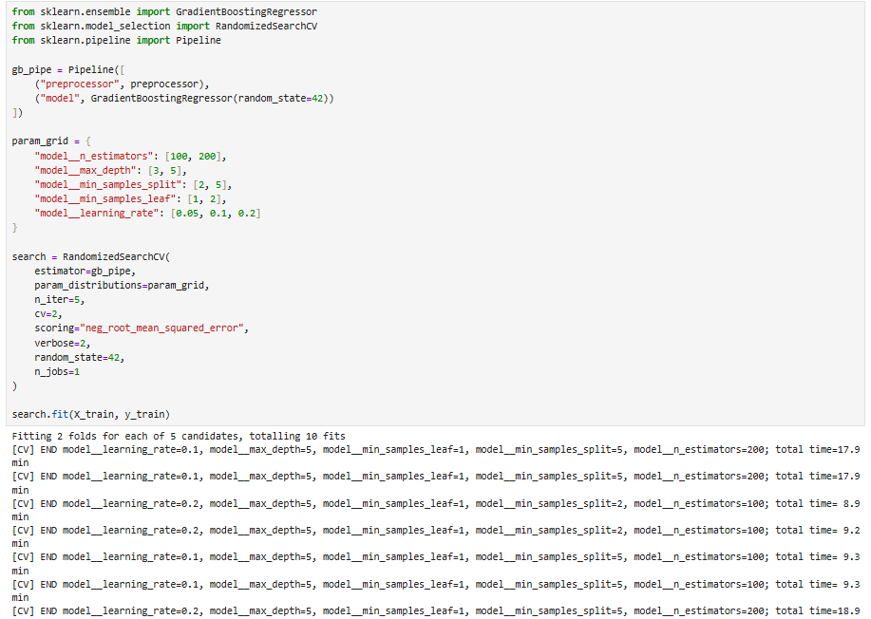
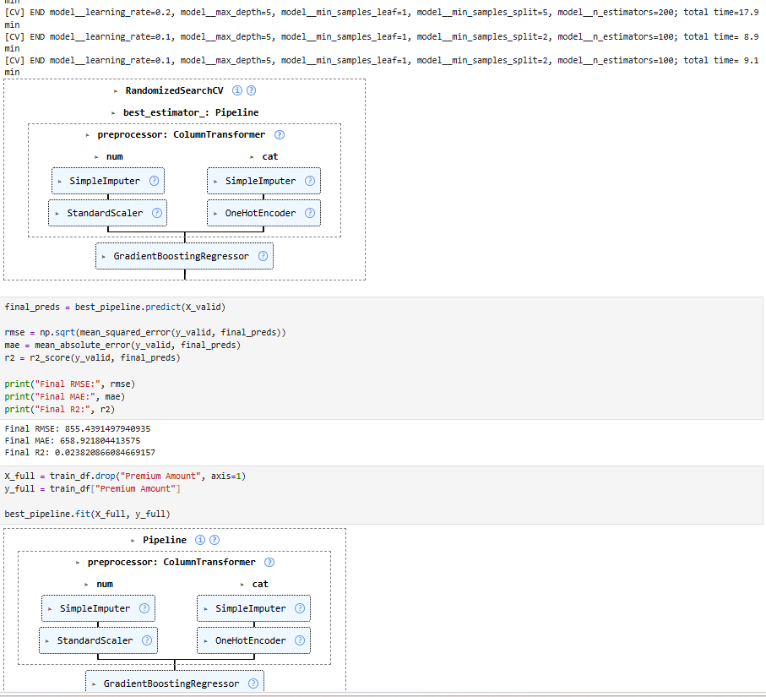
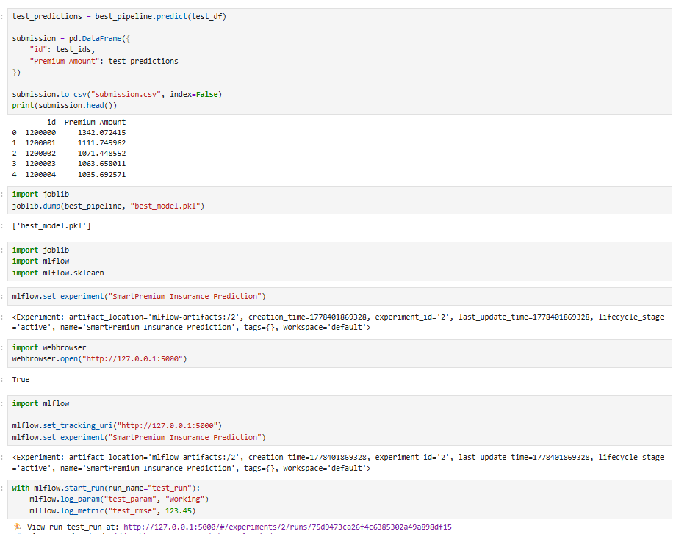
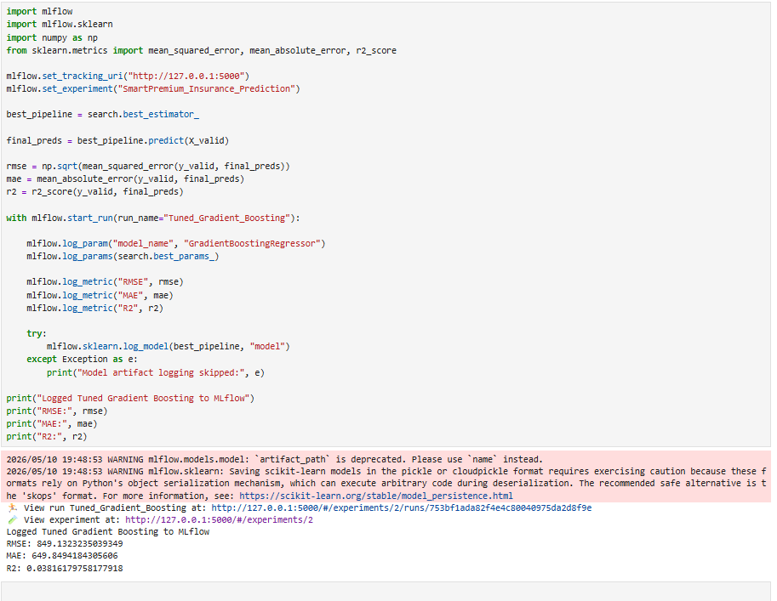
MLflow
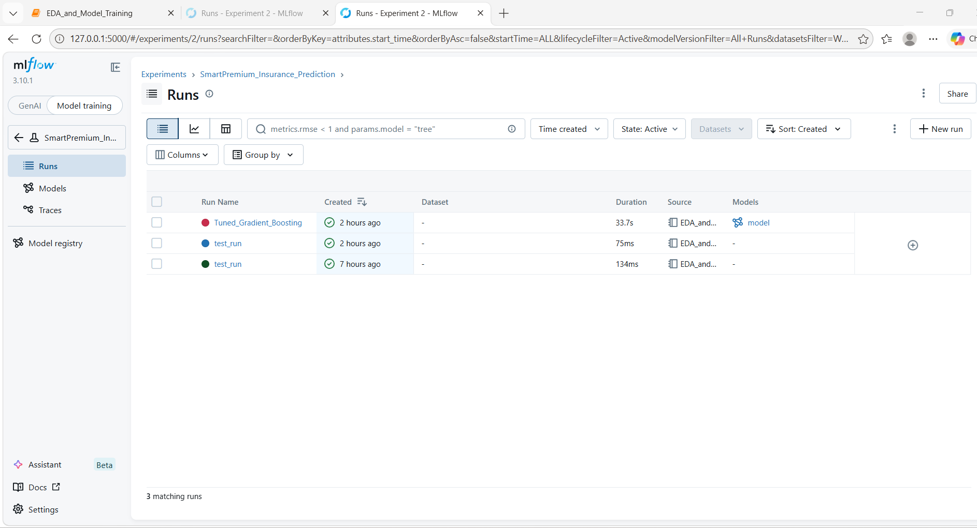

Streamlit app:
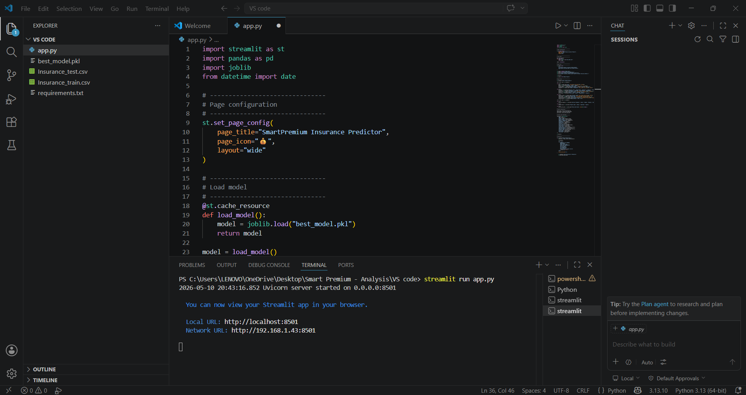
Final predicted premium amount:
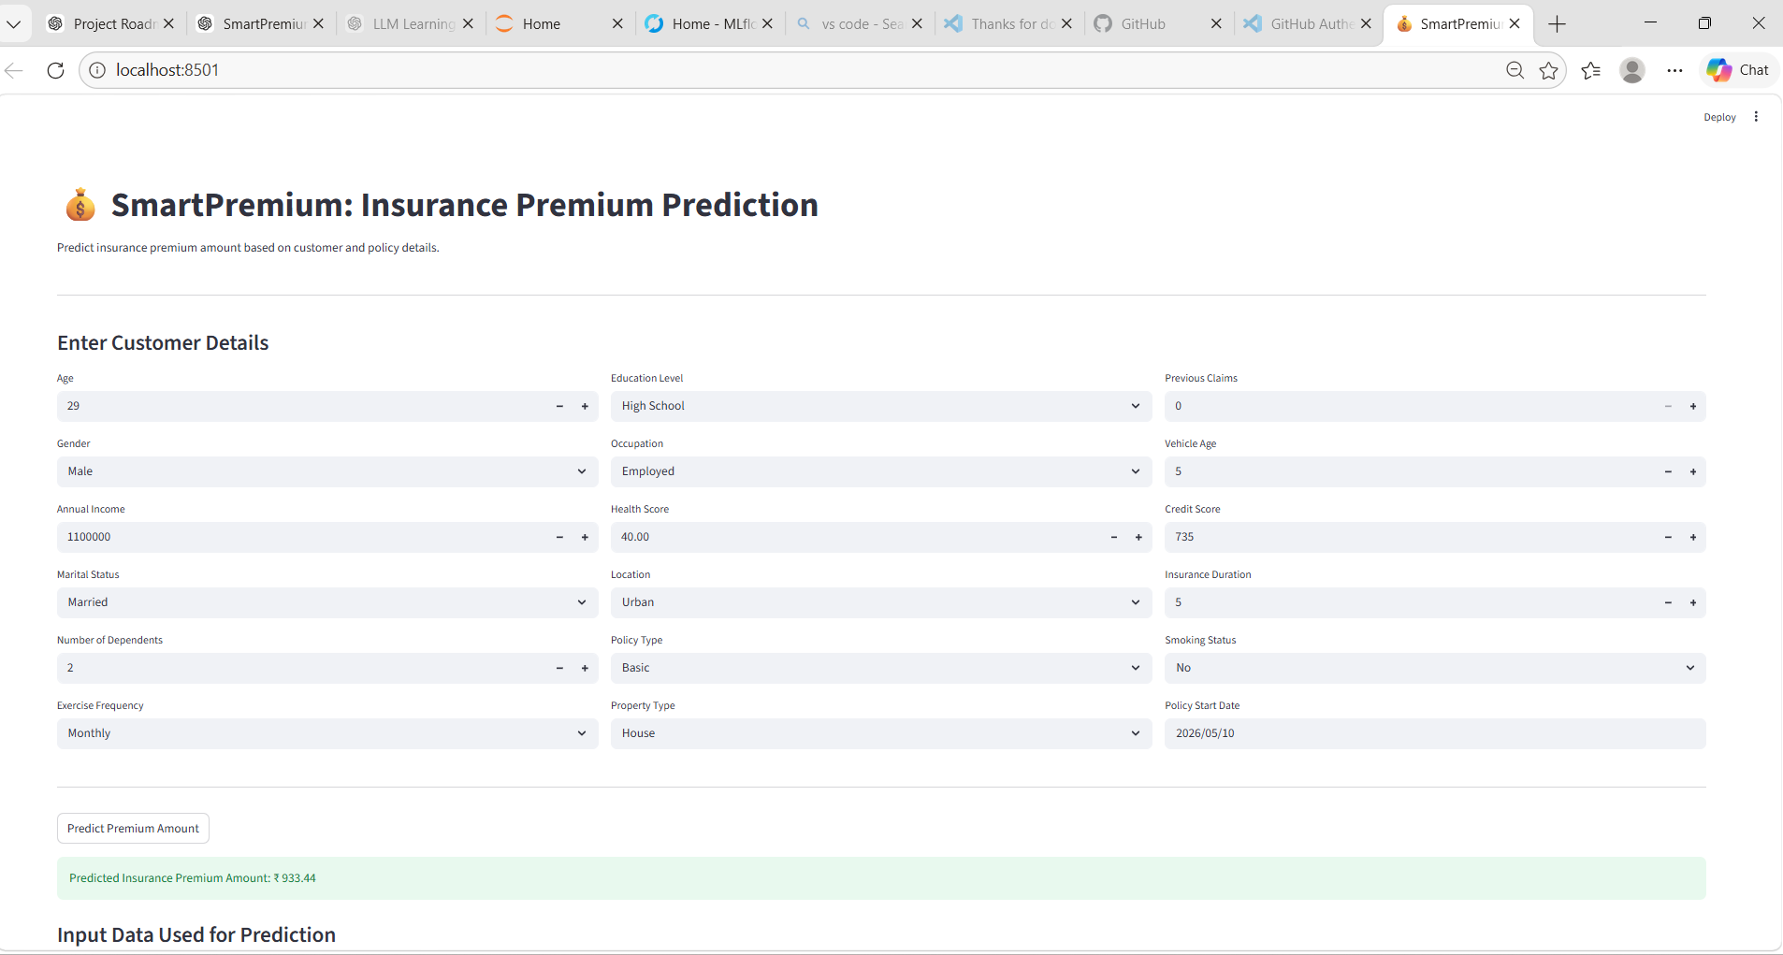
Conclusion:
Developed an end-to-end Machine Learning application to predict insurance premium amounts based on customer demographics, health details, financial history, and policy information. The project involved data preprocessing, exploratory data analysis (EDA), feature engineering, and model training using Scikit-learn. Hyperparameter tuning was performed using Randomized SearchCV with Gradient Boosting Regressor to improve model performance. MLflow was integrated for experiment tracking, parameter logging, and model management. Finally, the trained model was deployed as an interactive web application using Streamlit for real-time premium prediction.

